MD2201: Data Science

Name of the student: SUMIT UMBARE Roll No. 77

Div: IT-B Batch: B3

Date of performance: 23/02/2024

Experiment No.3

Title: Hypothesis Testing
Aim: i. To perform hypothesis testing for single sided tail.
ii. To perform hypothesis testing for Two-sided tail.

Software used: Programming language R.

Code Statement:
- Suppose the manufacturer claims that the mean lifetime of a ball bearing is 10000hours. The auditing team stated that the mean lifetime is less than what is claimed. On the basis of a randomly chosen sample of 50 ball bearings as given in the dataset, at 0.05 significance level, can we reject the claim of the manufacturer? What will be your interpretation if the significance level is made as 0.01? Consider the data set titled “Hypothesis_csv1.csv”.

- The nutrition label on a bag of potato chips says that a one ounce (28 gram) serving of potato chips has 130 calories and contains ten grams of fat, with three grams of saturated fat. A random sample of 35 bags yielded a sample mean of 134 calories with a standard deviation of 17 calories. Is there evidence that the nutrition label does not provide an accurate measure of calories in the bags of potato chips? We have verified the independence, sample size, and skew conditions are satisfied. Take alpha as 5% and 1%.

Code:

g<-read.csv("Expt 3- Dataset_Hypothesis_csv.csv")
m<-mean(g$Life_Hrs)
cat("\n Mean of Life Hrs is ",m)
s<-sd(g$Life_Hrs)
se<-s/sqrt(50)
cat("\n standard error value is ",se)
p<-pnorm( m,10000,se,lower.tail = T)
cat("\n Probability of Normal distribution is ",p)
if(p<0.05)
{
cat("\n claim can be rejected for 0.05")
}else{
cat("\n claim cannot be rejected for 0.05")
}
if(p<0.01)
{
cat("\n claim can be rejected for 0.01")

}else
{
cat("\n claim cannot be rejected for 0.01")

}
cat("\n \n \n case 2 ")
se1<-17/sqrt(35)
cat("\n standard error value is ",se1)
p2<-pnorm(134,130,se1,lower.tail = F)*2
cat("\n Probability of Normal distribution is ",p2)
if(p2<0.05)
{
cat("\n Null hypothesis can be rejected for 0.05")
}else{
cat("\n Null hypothesis cannot be rejected for 0.05")
}
if(p2<0.01)
{
cat("\n Null hypothesis can be rejected for 0.01")

}else
{
cat("\n Null hypothesis cannot be rejected for 0.01")

}

Results:

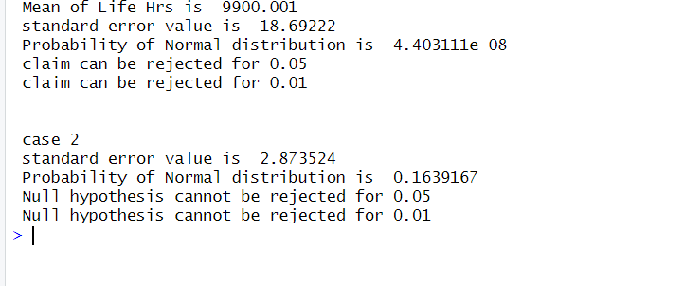

Conclusion:

